There are two parts to the exam. The first part is the short answer, second is an essay.
Part 1.
Answer the following questions using short answers (5 sentences maximum). Some questions may even be successfully addressed with a single sentence answer.
Questions:
Explain size-weight illusion and give an example of where it may occur in real life.

Perceiving an object of the same weight to be lighter when it’s size is greater.

How does rotational inertia of the object affects it’s perceived length?

As it get’s harder to rotate the object, the longer it seems

What did Gibson mean by terms “exteroception”, “proprioception”, and “exproprioception”? (6)
Perception of environmental properties, perception of self, perception of self with respect to the environment.

What phenomena does the Haken-Kelso-Bunz (HKB) equation describe?
Different kinds of coordination. E.g., between hands and people.

Using an example from one of the studies that we discussed in class, describe what is enhanced contrast effect in a dynamical system. You can also draw an illustration if needed.

It’s when a system tries to switch to an incoming behavior before it would have had it not had EC. Example, moving planks. People may shift to two-handed grasp faster – i.e., they could still use one hand, but switch in anticipation.

When we discussed coordination dynamics, I talked about the principle dynamical similitude. What is that principle and how has it been used in psychology?
Similar dynamical laws apply to different phenomena. E.g., HKB equation.

Name two features of self-organization.
No designer, no central plan, nobody knows exact future.

Describe the logic of the Donders’s subtractive method.
Perception occurs in stages. It’s possible to devise manipulations to engage only several stages. Then one can subtract the amount of time required to do for tasks with more stages and compare to the tasks with less stages to infer the required time for the processing of the stages that are present in the longer task.

What is component-dominant dynamics and how is interaction-dominant dynamics different?
Interaction-dominance is when operation of a component changes the operation of the other components.

During the last semester a student sent thousands of text messages, wrote hundreds of short answer essays, and a couple of long term papers. Sketch the likely distribution of her writing pattern. What is this distribution called?

power law

Given the following attractor landscape, 1) identify the attractors and repellers present in this system, 2) which one of the attractors is stronger?
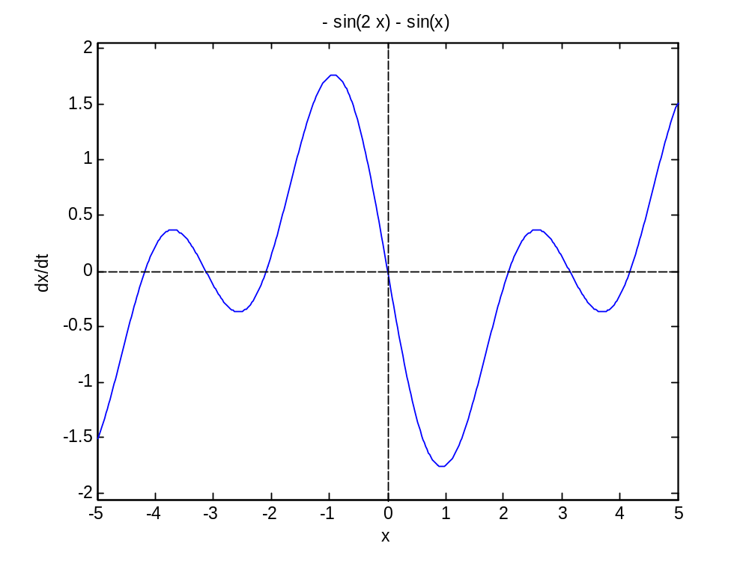
3 attractors
4 repellers
attractor at 0 is the strongest

Name at least two insights from our exercise in bathtub dynamics with regard to understanding of complex dynamical systems.
It takes time to enact change, one may reduce the outflow to increase the stock, one may increase the flow to increase the stock, system can be in dynamic equilibrium based on in and outflow balance.

Define a dynamical system and provide an example.
It’s a system that changes with time. Rock is an example.

Part 2. Essay
Address one of the questions below for the last portion of the exam. Your answer should be logically written text consisting of several paragraphs (introduction, main body, and a conclusion).
Questions:
We have frequently talked about the uses of physical analogies in psychology. Write a position essay arguing either in favor or against the use of such analogies in psychology. Please remember that at issue is how to move psychology forward and what strategy to use to develop new experiments. Think of the history too and the other approaches to perception-action phenomena that researchers have used.

Describe the concept of perception-action cycle in the context of dynamic touch experiments discussed in class. Make sure to define all relevant terms and explain concepts.

